***A* Algorithm***

import heapq

import matplotlib.pyplot as plt

from collections import defaultdict

# Priority Queue for openSet

class PriorityQueue():

    def __init__(self):

        self.heap = []

    def enqueue(self, item, priority):

        heapq.heappush(self.heap, (priority, item))

    def dequeue(self):

        return heapq.heappop(self.heap)[1]

    def isEmpty(self):

        return len(self.heap) == 0

# Reconstruct path from start to goal

def reconstructPath(parent, start, goal):

    current = goal

    full_path = []

    while current != start:

        full_path.append(current)

        current = parent[current]

    full_path.append(start)

    return full_path[::-1]  # Reverse the path to start -> goal

# Get valid neighbors of the current node

def neighbors(node, grid, allow_diagonal=False):

    x, y = node

    directions = [(-1, 0), (1, 0), (0, -1), (0, 1)]  # Up, Down, Left, Right

    if allow_diagonal:

        directions += [(-1, -1), (-1, 1), (1, -1), (1, 1)]  # Diagonals

    valid_neighbors = []

    for dx, dy in directions:

        nx, ny = x + dx, y + dy

        if 0 <= nx < len(grid) and 0 <= ny < len(grid[0]) and grid[nx][ny] == 0:

            valid_neighbors.append((nx, ny))

    return valid_neighbors

# Manhattan Distance heuristic

def manhattanDistance(node, goal):

    return abs(node[0] - goal[0]) + abs(node[1] - goal[1])

# Diagonal Distance heuristic

def diagonalDistance(node, goal):

    return max(abs(node[0] - goal[0]), abs(node[1] - goal[1]))

# A* Search Algorithm

def aStar(grid, start, goal, heuristic, allow_diagonal=False):

    openSet = PriorityQueue()

    openSet.enqueue(start, 0)

    parent = {}

    gScore = defaultdict(lambda: float('inf'))

    gScore[start] = 0

    fScore = defaultdict(lambda: float('inf'))

    fScore[start] = heuristic(start, goal)

    while not openSet.isEmpty():

        current = openSet.dequeue()

        if current == goal:

            return reconstructPath(parent, start, goal)

        for neighbor in neighbors(current, grid, allow_diagonal):

            tentative_gScore = gScore[current] + 1  # Cost from current to neighbor

            if tentative_gScore < gScore[neighbor]:

                parent[neighbor] = current

                gScore[neighbor] = tentative_gScore

                fScore[neighbor] = gScore[neighbor] + heuristic(neighbor, goal)

                openSet.enqueue(neighbor, fScore[neighbor])

    return None  # No path found

# Visualization function

def visualizePath(grid, path, start, goal):

    plt.figure(figsize=(8, 8))

    for x in range(len(grid)):

        for y in range(len(grid[0])):

            if grid[x][y] == 1:  # Obstacle

                plt.plot(y, x, 'ks')  # Black square for obstacles

    if path:

        for (x, y) in path:

            plt.plot(y, x, 'go')  # Path in green

    plt.plot(start[1], start[0], 'bo', label='Start')  # Start in blue

    plt.plot(goal[1], goal[0], 'ro', label='Goal')  # Goal in red

    plt.gca().invert_yaxis()

    plt.legend()

    plt.grid()

    plt.show()

# Example grid, start, and goal

grid = [

    [0, 1, 0, 0, 0],

    [0, 1, 0, 1, 0],

    [0, 0, 0, 1, 0],

    [0, 1, 0, 0, 0],

    [0, 0, 0, 1, 0]

]

start = (0, 0)

goal = (4, 4)

# Run A* with Manhattan distance

path_manhattan = aStar(grid, start, goal, manhattanDistance, allow_diagonal=False)

print("Path with Manhattan Distance:", path_manhattan)

visualizePath(grid, path_manhattan, start, goal)

# Run A* with Diagonal distance

path_diagonal = aStar(grid, start, goal, diagonalDistance, allow_diagonal=True)

print("Path with Diagonal Distance:", path_diagonal)

visualizePath(grid, path_diagonal, start, goal)

***Output :***

Path with Manhattan Distance: [(0, 0), (1, 0), (2, 0), (2, 1), (2, 2), (3, 2), (3, 3), (3, 4), (4, 4)]

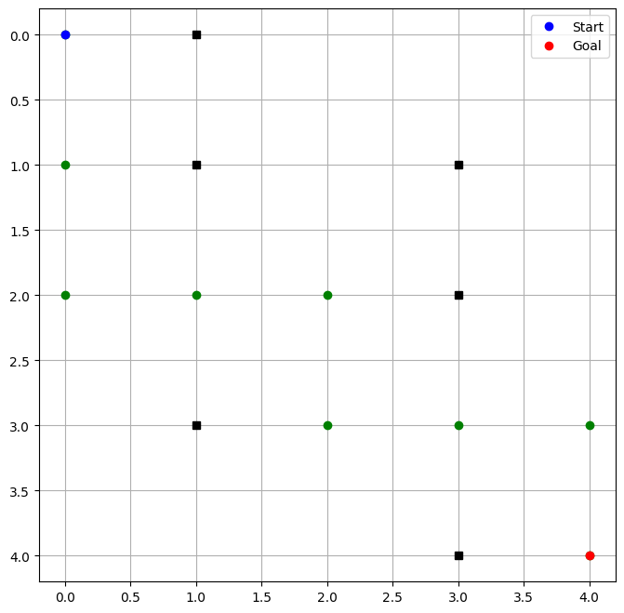

Path with Diagonal Distance: [(0, 0), (1, 0), (2, 1), (2, 2), (3, 3), (4, 4)]

